Emergence of Creativity in Design, the Emergence of Design in Creativity
William Smith and Smith William
University of the Universe, City, USA
Corresponding author’s email address
This paper aims at contributing to a better understanding of the emergence of new ideas in design situations. Towards this end, we first present a descriptive model of creative design activities: the analogy and constraint management model. Then, we describe the methods we use to gather data and perform analyses of designers' cognitive processes. To illustrate them, two experiments are presented. They aim at identifying designers' sources of inspiration and ideas, at determining how they reach such ideas, and at characterizing to which extent these ideas can be considered as original. The results we obtain allow us to define conditions for enhancing creativity.
Creative design activities
We argue that design activities offer a favored area to analyze the emergence of creativity since designers have to reach a design solution (or to define an artifact), which is both new and adapted to certain requirements or constraints [1]. Depending on the situations, the novelty can be more or less important but the design solution should present at least some new features by comparison with pre-existing products in the design area. To characterize the evolution of the design process, we first comment on the "spiral representation" (inspired by Zeisel [2]; see Figure 1.
A main characteristic of creative tasks, such as design tasks, is that the initial state is "ill structured" [3], [4], and [5]. Thus, the designer's mental representation is, initially, incomplete and imprecise. Therefore, the research space of ideas and potential solutions are, at the beginning, relatively large (see the left part of Figure 1). Then, the designer's mental representation evolves as the problem solving progresses and the research space of potential solutions is progressively restricted (see the right part of Figure 1) until the designer reaches a design solution that is considered as satisfying certain criteria. Thus, a co-evolution of problem and solution spaces can be [6]. Each designer constructs his/her own representation of the design problem and deals with a problem that has become specific to him/her. It is especially due to the fact that designers can adopt various points of view and develop opportunistic reasoning. Therefore, design problems are “open-ended”: a given problem admits various solutions, which depend on the points of view and criteria that are favored.

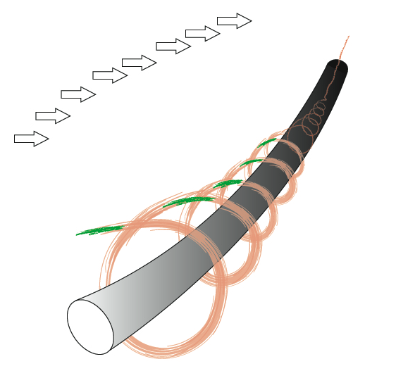
Fig1. The spiral model of the development of whatever

More detail with a heading 2
A specific cognitive process that we wish to study is related to the dynamic of the individual design process and, especially, to "conceptual leaps" that occur all along the design activity. Thus, complementary questions can be addressed:
- How can designers evoke creative ideas?
- What are their sources of inspiration?
- Can we identify some specific types of sources of inspiration that are more useful than others to reach creative ideas?
- Can we stimulate designers' evocation process and, on this basis, enhance creativity in design activities?
What can be seen in Table 1 is that the table contains the contents of a table to show how it looks.
Table 1 Relationships between author s and definitions
Author | Definition of  creativity | Verb/ Verb  phrase | Qualifier | Noun/ Noun  Phrase | Qualifier
Amabile | The process by which something judged (to be creative) is produced |  |  | Process | something judged is produced
Charles Thompson | Creativity consists of coming up with many ideas, not just that one great idea | coming up with many ideas | not just that one great idea
Heikkila | Creativity is the ability to produce new ideas and solutions |  |  | Ability | produce new ideas and solutions
M. Stein | Process that results in a novel work that is useful |  |  | Process | results in a novel work that is useful
Rollo May | Creativity is the process of bringing something new into being |  |  | Process | bringing something new into being
References
1. Denzin NK, Lincoln YS (2003) The landscape of qualitative research: theories and issues, 2nd edn. Sage Publications, Thousand Oaks
2. Mays N, Pope C (2000) Qualitative research in health care. Assessing quality in qualitative research. Br Med J 320:50–52
3. Spradley JP (1994) The ethnographic interview. Holt, Rinehart, & Winston, New York
4. Helitzer-Allen D, Makhambera M, Wangel A (1994) Obtaining sensitive information: the need for more than focus groups. Reprod Health Matters 3:75–82
5. Ulin PR, Robinson ET, Tolley E (2005) Qualitative methods in public health: a field guide for applied research. Family Health International and Jossey-Bass,San Francisco
6. Goering PN, Streiner DL (1996) Reconcilable differences: the marriage of qualitative and quantitative methods. Can J Psychiatry 41:491–497
7. Bauman LJ, Adair EG (1992) The use of ethnographic interviewing to inform questionnaire construction. Health Educ Q:19:9–23.
8. Sheon N, Crosby MG (2004) Ambivalent tales of HIV disclosure in San Francisco. Soc Sci Med: 58:2105–2118.
9. Koester KA, Maiorana A, Vernon K, et al. (2005) HIV surveillance in theory and practice: assessing the acceptability of California’s non-name HIV surveillance regulations. Health Policy.
10. Patton MQ (1990) Qualitative evaluation and research methods. 2nd ed. Newbury Park: Sage Publications.
11. Patton MQ (2002) Qualitative evaluation and research methods. 3rd ed. Thousand Oaks: Sage Publications.

